**GEOGRAPHIC INFORMATION SYSTEMS 1 – SCIENTIFIC DATA**

**UMEÅ UNIVERSITY – DEPARTMENT OF ECOLOGY & ENVIRONMENTAL SCIENCE**

**LAB3 – ASSIGNMENT 3**

**LAB3.1 Reading Comprehension**

**LAB3.2 Lab3 questions**

**LAB3.3 ArcGIS maps**

**LAB3.4 Map questions**

**LAB3.1 – READING COMPREHENSION**

**Tree invasion within a pine / grassland ecotone: an approach with historic aerial photography and GIS modeling. Joy Nystrom Mast, Thomas T. Veblen, Michael E. Hodgson, 1997.**

**Channel sinuosity of the Körös River system, Hungary/Romania, as possible indicator of the neotectonics activity. Judit Petrovszki, Gábor Timár, 2010.**

**LAB3.1.1**

**In the article by Petrovszki & Timár (2010), critique the maps shown in Figures 1-3. Based on their map layouts and design, are they effectively communicating the purpose of their maps? Give at least two positive aspects of the maps and two points that you would improve.**

**Map 1** shows the location of the study area, which is apparently it main purpose. Without any doubt, this map gives good and effective information about the context of the Körös system through its map layout, which clearly shows the topography of the area. Additionally, the main rivers network is also well defined, which is essential to complete its context information.

However, country limits, which are mentioned in the article1 (Judit Petrovszki, Gábor Timár, 2010, p223) andconveniently labelled on the map, are not shown on the map. Undoubtedly, overlaid information about these limits would be considerably useful.

Regarding to **Map 2**, its purpose is to show Körös system, and how its rivers *“converge into one trunk river, reaching the Tisza in its middle section”* 1 (Judit Petrovszki, Gábor Timár, 2010, p223).

However, although the rivers system is properly shown and labelled, Tisza River is completely missing on this map, where it has not even been depicted or labelled. Adding this information to map 2, would give it a common element with map 1, which would help to properly understand the context.

When it comes to **Map 3**, its main purpose is apparently to show one of the pre-regulation channels, which were built during the second half of the nineteenth century, and which decreased river lengths by 55% 2 (Ihrig et al. 1973).

In this map, although the new channel can be easily recognised as one of the main infrastructures of the area, it is actually because of its geometry in contrast with the rest of natural rivers. Its representation method could be easily improved by properly labelling the channel.

**LAB3.1.2**

**Methods:**

1. **What criteria were used to decide where and how many points should be used to digitize the Körös River system?**

In order to digitise this survey, *“polylines were digitised along the middle of the river beds”* and the digitising point were *“not equidistant, there are more in the bends, and less in the straighter parts”*. 1 (Judit Petrovszki, Gábor Timár, 2010, p227).

Afterwards, in order to compute sinuosity, *“a series of point are needed, in which the distance are equidistant to each other. Therefore, the original digitized polyline was converted to a new one with equidistant vertices. The equal distance of 50m was interpreted along the original polyline”*.

1. **Which features were digitized in the study on tree invasion by Mast et al. (1997)?**

Topographic maps (and features included in it) help to identify urban areas and wooded cover within the ecotone for its analysis. *“Digitised features using AutoCAD and GIS program IDRISI included all* ***urban areas, lakes, non-wooded areas, and wooded areas within non-wooded areas****”* 3 (J N Mast, T T Veblen, M E Hodgson, 1997, p186).

1. **In your own words, briefly describe how Mast et al. (1997) quantified the amount of tree cover based on the historical aerial photographs**

After digitising historical aerial photos, tonal differences between different types of trees and between these and grasslands, could be easily identified with digital methods. This allowed to digitally quantify different types of tree cover and grassland areas.

**REFERENCES**

1. Petrovszki, J. and Timár, G. (2010). Channel sinuosity of the Körös River system, Hungary/Romania, as possible indicator of the neotectonic activity. Geomorphology, 122(3-4), pp.223-230.
2. Ihrig, D., Károlyi, Zs., Károlyi, Z., Vázsonyi, Á. (Eds.), 1973. A magyar vízszabályozás története. Országos Vízügyi Hivatal (OVH)-Vízügyi Dokumentációs és Tájékoztató Iroda (Vizdok), Budapest. 398 pp.
3. Mast, J. N., Veblen, T. T., & Hodgson, M. E. (1997). Tree invasion within a pine/grassland ecotone: an approach with historic aerial photography and GIS modeling. Forest Ecology and Management, 93(3), 181-194.

**LAB3.2.1 Lab3 Q1**

**What is the name of River X? What catchment is River X a part of?**

First of all, we can easily figure out the name of River X by overlaying the shapefile ‘Rivers_streams_swe’, which is part of Lab2 data, onto the Lab3 layers inserted in ArcMap. By selecting the segment of river within the study area, it can be checked within the attributes table, that its name is **Klarälven River**.

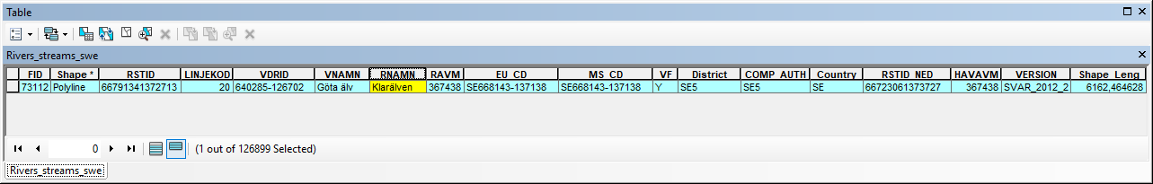

In this table, we can also see that Klarälven River is part of **Göta älv River Catchment**.

**LAB3.2.2 Lab3 Q2 - Metadata: Table of files**

**Create a table of your files used and created in this lab. Make sure your table contains the same five columns as the metadata table from the last lab: name of file, projection/coordinate system, description of data in the file, source, tool/method used to create the file.**

A preview of the created excel schedule, including received and newly created filed, can be seen hereunder, as well as in an excel file included in the submission in the Drop Box.

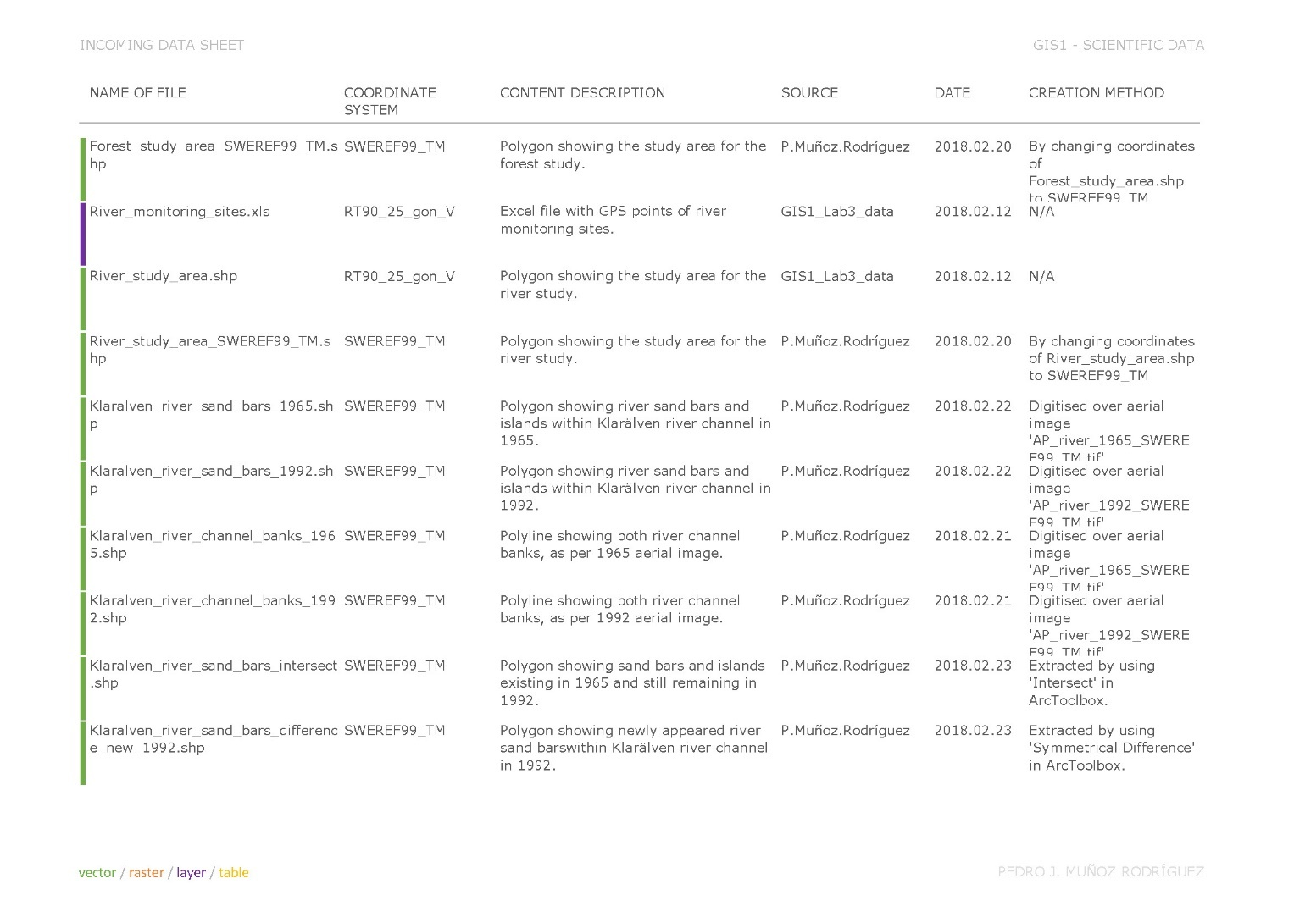

**LAB3.2.3 Lab3 Q3 - Metadata: Insert screenshots of your metadata**

**Insert screenshots of the metadata that you have edited in two of the new shapefiles: include the forest coverage and one of the channel edge files.**

The image hereunder is an example of metadata of the shapefiles extracted by ArcToolbox operations from datasets digitised over the aerial images.

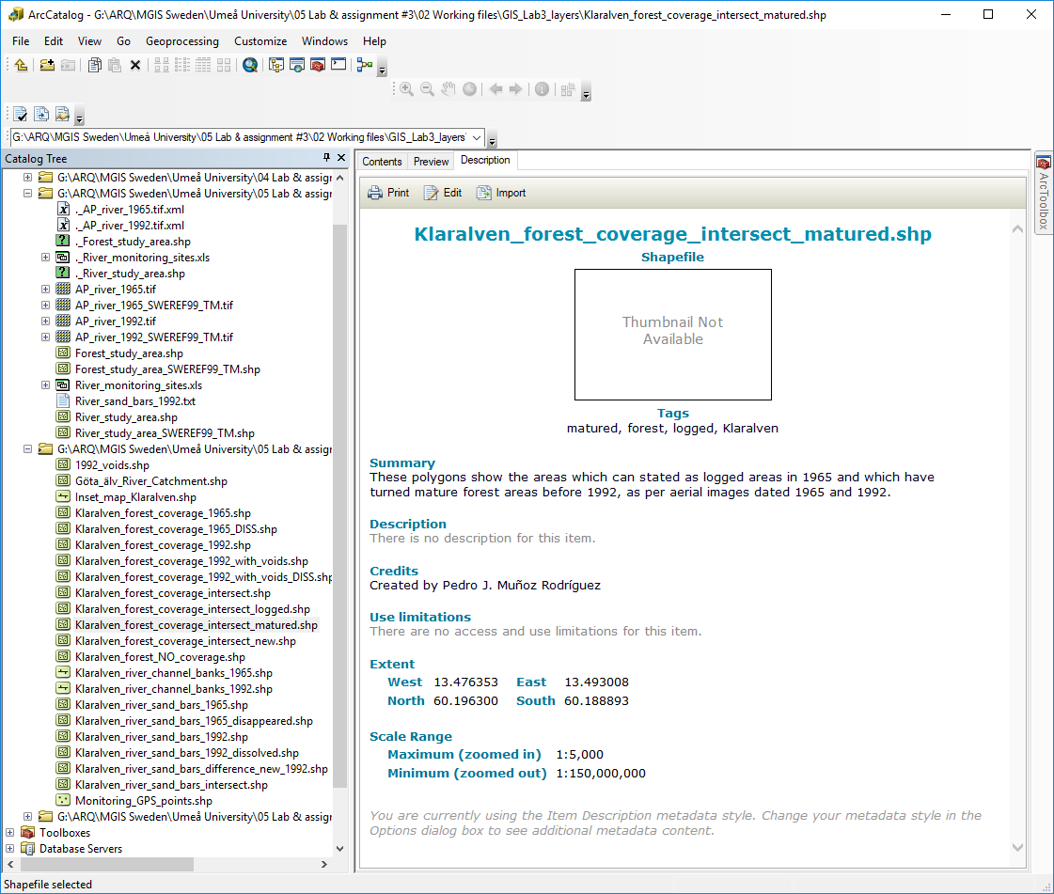

The example below is to show the metadata of the river channel shapefile digitised over the aerial image dated 1965.

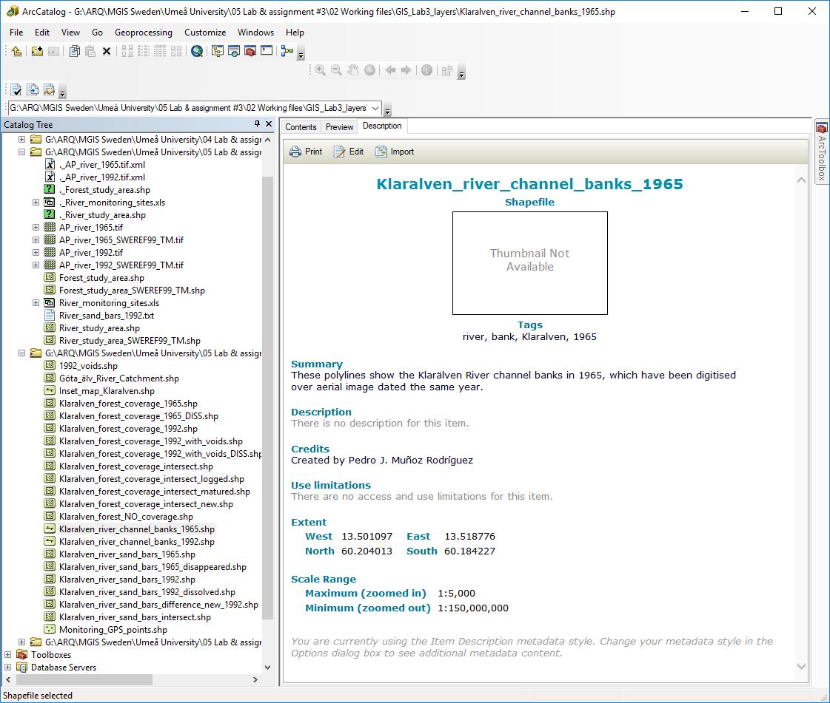

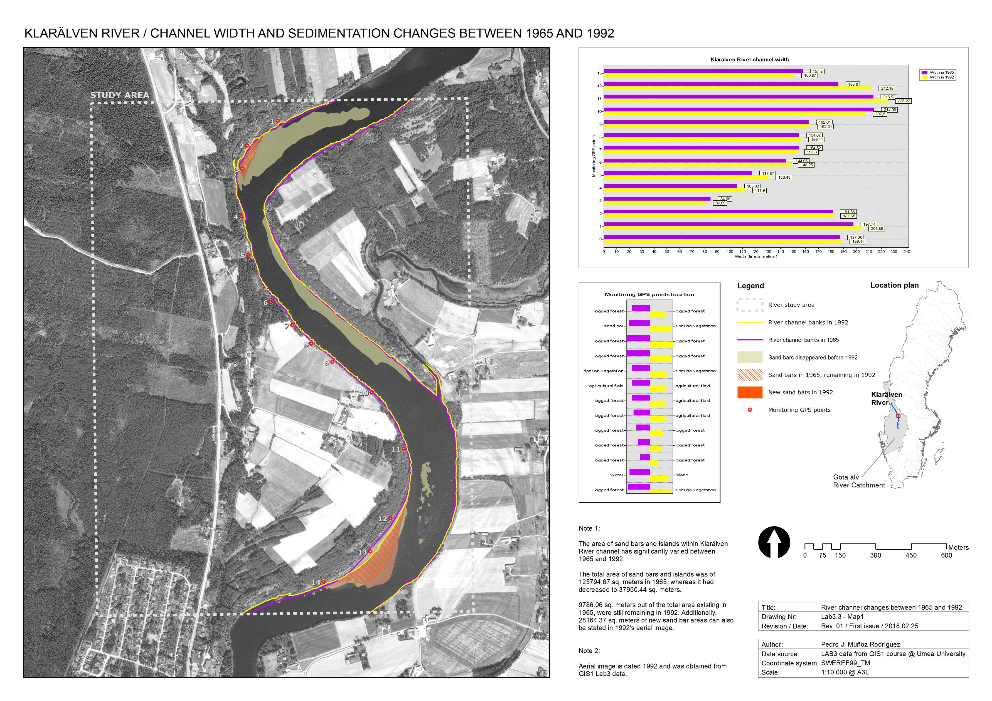

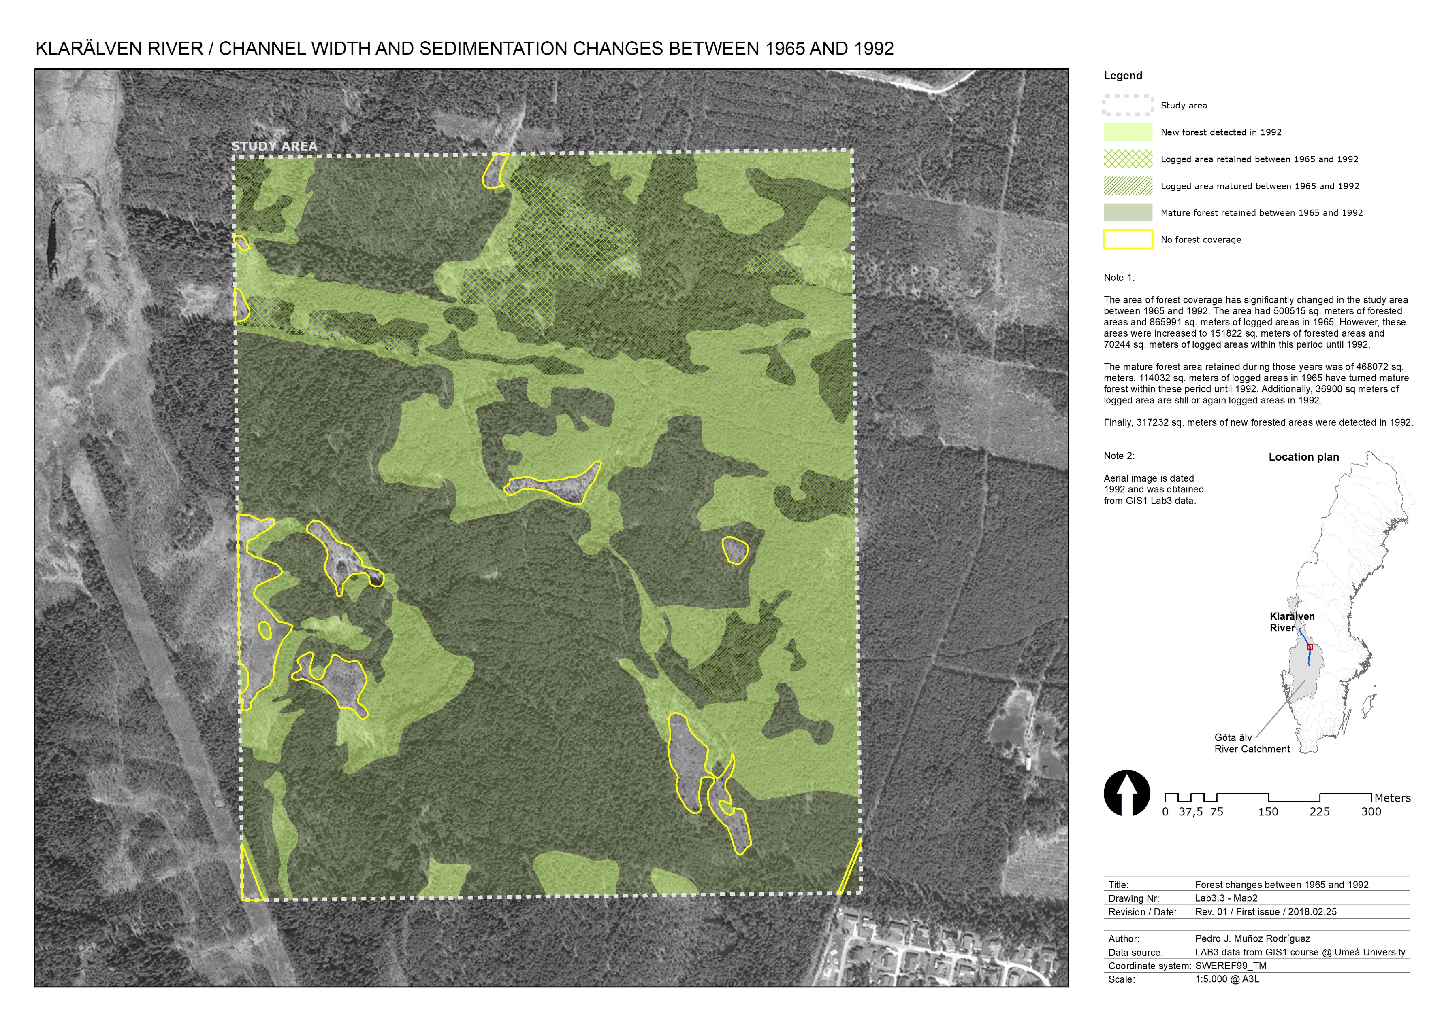

**LAB3.4 – MAP QUESTIONS**

**LAB3.4.1**

**Map layout explanation: include a short explanation of your map layout. How does your map layout and design help you to communicate the purpose of your maps?**

The intention of the designed layouts is, not only to show the received or the digitised data, but also to give as many answers as possible to possible future users of these maps, i.e. it shouldn’t be the user’s task to analyse all the data contained in the map, but this map should already show its intention and also certain conclusions. E.g. it doesn’t tell me too much to just show logged and forested areas in 1965 and 1992. It is absolutely more interesting to analyse these data to see if forested areas have been retained or not in this period of time, or if there is a certain evolution of them that can be observed.

For this reason, I tried to design my layouts in a considerably similar way that allow me to always include certain information in an organised way, such as text notes or diagrams that support the information shown on the map and the legend. Obviously, this doesn’t mean to have repeated information across the layout, but to show data in different ways to explain a common purpose.

This is the case of the diagrams shown in layout 1, whose method I have been exploring in ArcMap for this assignment, although I assume that its use and results obtained could be improved in further assignments. Shown text notes try to give some extra details and numbers, and to create a dialog with the other elements of the layout: map, key and diagrams.

In my opinion, when it comes to produce a clear and effective map layout, it is whether the dialog among the different elements of the layout is produced or not, that can make all the difference for the map user to understand the information contained and its purpose.

**LAB3.4.2**

**Using your observations and measurements, describe how the channel form of River X changed between 1965 and 1992.**

* **Include data/observations on changes in the location of the channel (is it in the exact same location or has it migrated/moved?), the shape of the meanders, and the type of vegetation found along the channel where the monitoring sites are located.**
* **In your text or in the form of a table that are referred to in the text, you should provide precise data on changes in channel width and the number of and area of sand bars/islands.**

Considerable changes in Klarälven River channel form can be observed in the aerial images dated 1965 and 1992. Changes of channel width within that period can be stated in table 1.



Table 1

According to the monitoring GPS points along the right edge of the river within the study area, some changes can be also observed in the type of terrain in which these points were in 1965 and in 1992, i.e. some points, which used to be in logged forest areas, are now located in agricultural fields. These changes can be observed in Table 2.

Looking at the map, an intensification of the meander shapes can also be observed.



Table 2

The area of sand bars and islands within Klarälven River channel has significantly varied between 1965 and 1992.

The total area of sand bars and islands was of 125794.67 sq. meters in 1965, whereas it had decreased to 37950.44 sq. meters.

9786.06 sq. meters out of the total area existing in 1965, were still remaining in 1992. Additionally, 28164.37 sq. meters of new sand bar areas can also be stated in 1992's aerial image.

Graphic details of these area changes can be also observed in map ‘Lab3.3 - Map1’.

Number of sand bars/islands and their areas in both years 1965 and 1992, as well as the total area of sand bars/islands, can be observed in Table 3 and Table 4.

|  |  |
| --- | --- |
| **Sand bar areas in 1965** | **Area sq. Meters** |
| **1** | **51532,17525** |
| **2** | **3806,597028** |
| **3** | **111,7385747** |
| **4** | **89,37629882** |
| **5** | **373,8862764** |
| **6** | **15,56902755** |
| **7** | **6,306016186** |
| **8** | **123,5354033** |
| **9** | **81,30686624** |
| **10** | **133,8932869** |
| **11** | **35,44893964** |
| **12** | **292,8433276** |
| **13** | **13,26167527** |
| **14** | **30887,03536** |
| **15** | **44,41793158** |
| **16** | **123,2781363** |
| **17** | **40,20610359** |
| **18** | **67,49005433** |
| **19** | **113,561418** |
| **20** | **26,70116228** |
| **21** | **37876,03692** |
| **TOTAL AREA** | **125794,6651** |

Table 3

|  |  |
| --- | --- |
| **Sand bar areas in 1992** | **Area sq. Meters** |
| **1** | **6720,265948** |
| **2** | **259,8817251** |
| **3** | **30970,28791** |
| **TOTAL AREA** | **37950,43558** |

Table 4

**LAB3.4.3**

**Using your observations and measurements, describe how the forest cover changed between 1965 and 1992 in the forest study area.**

* **Be specific and include details about the number and area of forested and logged areas.**

The area of forest coverage has significantly changed in the study area between 1965 and 1992. The area had 500515 sq. meters of forested areas and 865991 sq. meters of logged areas in 1965. However, these areas were increased to 151822 sq. meters of forested areas and 70244 sq. meters of logged areas within this period until 1992.

The mature forest area retained during those years was of 468072 sq. meters. 114032 sq. meters of logged areas in 1965 have turned mature forest within these period until 1992. Additionally, 36900 sq. meters of logged area are still or again logged areas in 1992.

Finally, 317232 sq. meters of new forested areas were detected in 1992.

Graphic details of these area changes can be also observed in map ‘Lab3.3 – Map2’.

**LAB3.4.4**

**Briefly provide possible explanations for the changes in channel form and forest cover described above.**

When it comes to factors that could have intensified this re-foresting process, the abandonment of agricultural crops during those years could be possibly one of the main ones.

It is also the slower stream that could be considered as a cause for decrease of sand bar areas, since more calmed water will certainly carry much less sediments in its stream.

When it comes to factors that could have intensified this re-foresting process, the abandonment of agricultural crops during those years could be possibly one of the main ones.

Additionally, considerably rapid improvements in fire protection in natural areas, has allowed the chance of many young forests to become mature forests.